Capstone Project Proposal

*Sai Teja Chava*

**

**Business Goal**

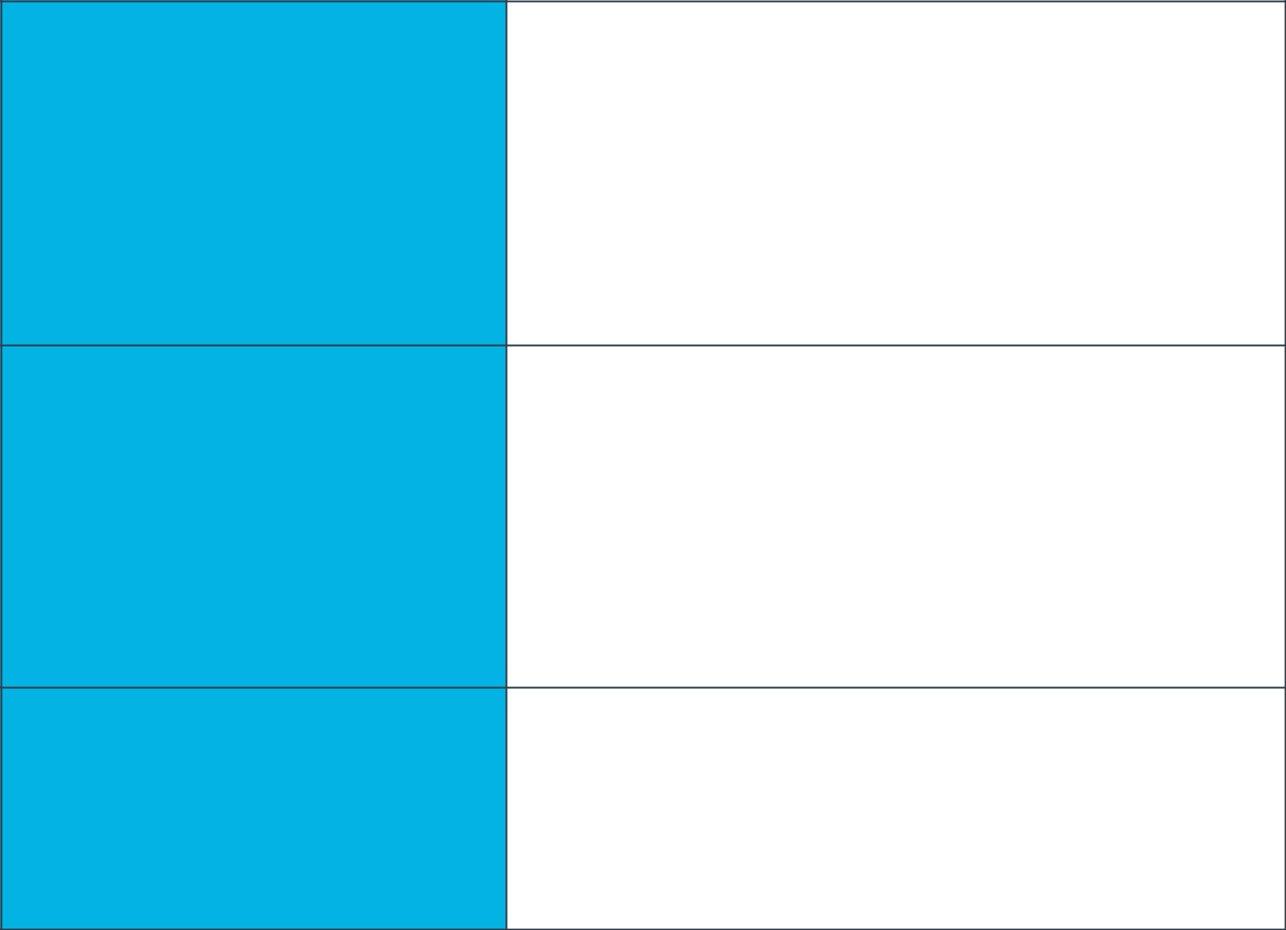

**Project Overview and Goal**

Project name: Automatic license plate recognition.

The industry problem that I am trying to solve is to automatically find license plate and the characters in the license plate given an image using computer vision techniques. With the rise of deep learning in recent years, CNN’s have become widely popular with Object Detection techniques. They are able to achieve much higher accuracies that have never been seen before. Hence ML/AI seems to an appropriate one in solving this task. By using AI/ML and achieving much higher accuracies for this task, the client say police department can benefit from it by levying fine on the people who have driven overspeed or jumped the signal etc.

What is the industry problem you

are trying to solve? Why use ML/AI

in solving this task? Be as specific

as you can when describing how

ML/AI can provide value. For

example, if you’re labeling images,

how will this help the business?

Every year police department loses millions of dollars in terms of revenue it can obtain through fines as there are limited police staff that monitor driver’s on streets. Also, drivers have become reckless in following the rules like speed, signal etc. which is not good for the safety of himself as well as others travelling with him on the road. So, by building this product, police department need not monitor all drivers on the road with more police staff and hence could save money on staffing. They could also levy fines on all drivers that do not follow rules and get more revenue. As more and more drivers keep getting fined, they start following the rules and all other good drivers are happy as the safety metric will go up. It is projected that the global automatic number plate recognition market will grow to more than USD 1,100 million by 2023. Rival companies would be “genetec”, “Siemens” etc. Since the market is huge and pretty new, there is no on company that has a really huge share and our company could cash this.

**Business Case**

Why is this an important problem

to solve? Make a case for building

this product in terms of its impact

on recurring revenue, market

share, customer happiness and/or

other drivers of business success.

**Application of ML/AI**

I will use ML/AI to find the license plate in image. Once the license plate is found, I will again use ML/AI to find the characters in the license plate. The business outcome or object that I am trying to achieve is to levy fines on all the drivers that do not follow rules and increase the revenue generated through fines. Also keep all other good drivers on the road happy by increasing safety metric through being harsh on bad drivers.

What precise task will you use

ML/AI to accomplish? What

business outcome or objective will

you achieve?

**Success Metrics**

**Success Metrics**

The business metrics that I would apply to determine the success of the product are increase in revenue generated through fines by police department and number of accidents that are taking place in the city. If revenue goes up and/or number of accidents come down, then that is good sign that the product is a success. To establish a baseline value and provide a point of comparison, we can collect the stats about the revenue generated and number of accidents before the product is deployed and compare them with the stats after the product is deployed.

What business metrics will you

apply to determine the success of

your product? Good metrics are

clearly defined and easily

measurable. Specify how you will

establish a baseline value to

provide a point of comparison.

**Data**



There are number of well-known academic datasets available for this task for free. So, I would use them initially in prototyping. Since using only academic data might not be good as it might not represent the real-world scenario’s, I would do some data collection myself and annotate using platforms like figureEight. Since all this data has images of cars and their license plates, this data is sensitive, and we need to be careful and make sure that we are obeying all laws here. That is reason why usually academic datasets say not to use them for commercial purposes unless given permission by the dataset owner. Since this data collection and annotations is not a cheap task as it can take few thousand dollars to much higher based on the amount of data you want to collect. We can collect the data as on-going process and keep refreshing model based on how well it is performing. Hence, we can have a total of 2000 images used for training by having 1000 from academic dataset and reduce the cost to say 2000 – 3000 dollars for collecting and annotating around other 1000 images.

**Data Acquisition**

Where will you source your data

from? What is the cost to acquire

these data? Are there any

personally identifying information

(PII) or data sensitivity issues you

will need to overcome? Will data

become available on an ongoing

basis, or will you acquire a large

batch of data that will need to be

refreshed?

Source is a mix of academic dataset and personal collection and annotation. When you take academic datasets, or even when you are collecting the data on your own, usually all these images are collected in daylight and hence there might be a bias of more day images than night images. If that is the case, then model might not do well in the night time and you need to make sure that data is balanced. Also, the images that you collect might be taken in different poses and angles than what our product would capture in real-time. So, you need to make sure that your dataset accounts for it.

**Data Source**

Consider the size and source of

your data; what biases are built

into the data and how might the

data be improved?

There are two tasks involved in this. One is to find license plate in images and draw a bounding box around them. Once bounding box is drawn the label given is “license plate”. For our model to be robust enough, we would have another class as other and let annotators draw some bounding boxes and label them as other so that out model learns patterns for license plate vs others. for that task three labels were chosen. “yes”, “no” if there is license plate and there isn’t and also “unknown” to account for uncertainty. The second task is to find characters in license plate. For this all chars and numbers were chosen as labels. Again and “unknown” label is included to account for uncertainty. This approach keeps it simpler and more straight forward than any other approaches, but the downside is say if we want to later tomorrow down the line want to have more fine grained labels like car plates, motorbike plates etc. this would not be possible with this.

**Choice of Data Labels**

What labels did you decide to add

to your data? And why did you

decide on these labels versus any

other option?

**Model**

**Model Building**

I will initially do a quick prototype by building the model using Automated ML tools/services like Google Auto ML or Amazon SageMaker. Once I am able to observe that I am able to do what I wanted to do, I will go over the metrics and see if the model is achieving the performance that would be good enough for me. If it is then I go ahead with the model, else I will try to see where I can improve the model like adding more data etc. If I am still not satisfied with the performance of the model, then I try to build the model using in house team as Automated ML tools do not perform well in all use cases.

How will you resource building the

model that you need? Will you

outsource model training and/or

hosting to an external platform, or

will you build the model using an

in-house team, and why?

**Evaluating Results**

Very common metrics like precision, recall, F1-score can be used. Usually you would want to detect all the license plates in the image and all the characters in it. So, you want this to be as high as possible like above 98.0 or 99.0 %.

Which model performance metrics

are appropriate to measure the

success of your model? What level

of performance is required?

**Minimum Viable Product (MVP)**

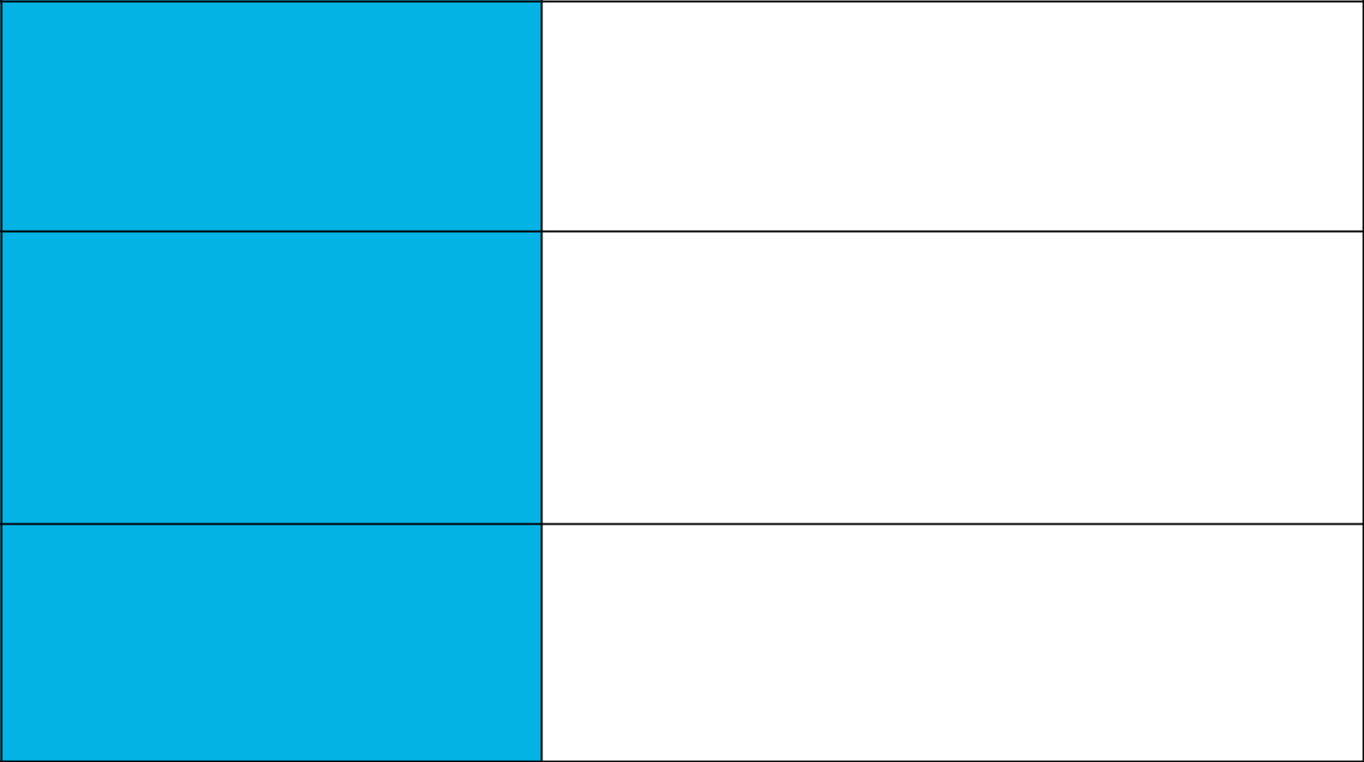

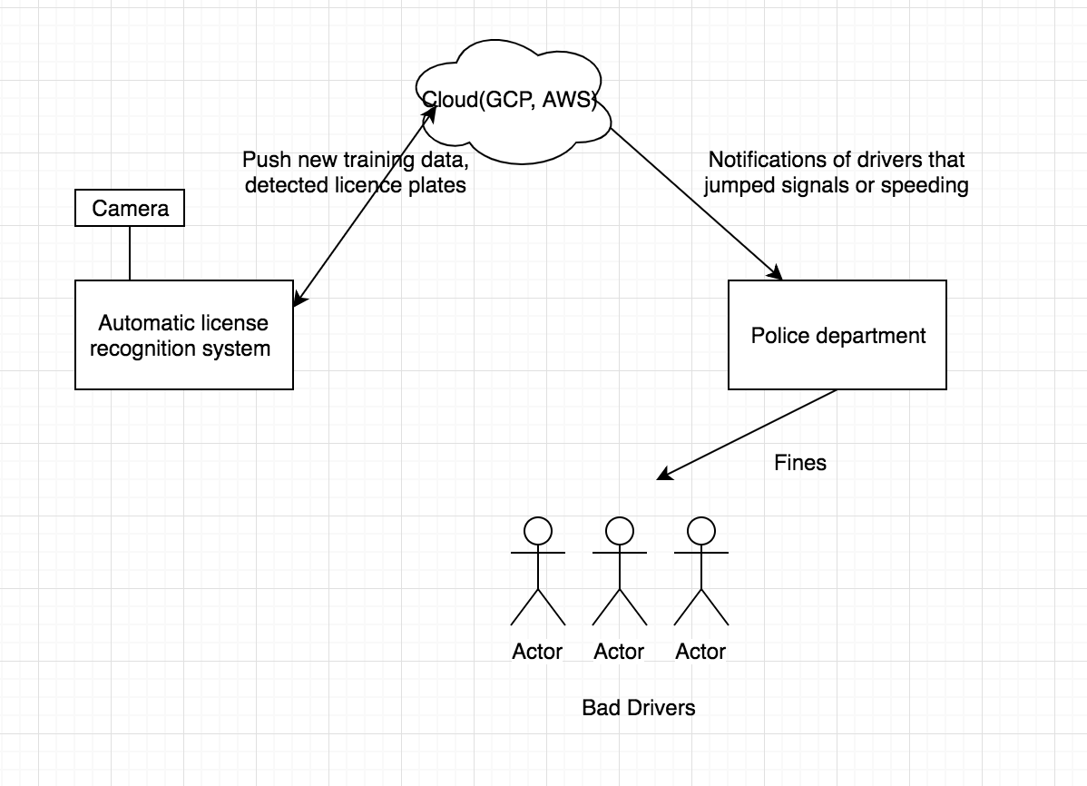

**Design**

What does your minimum viable

product look like? Include sketches

of your product.

**Use Cases**

As mentioned earlier, this product can be used by police department by placing them at signals or at some spots on freeways so that they can automatically fine drivers that jump signals or overspeed. This product can also be used by industries to detect the license plates of the vehicles and allow them to enter (open the gate) automatically if they are legitimate vehicles etc.

What persona are you designing

for? Can you describe the major

epic-level use cases your product

addresses? How will users access

this product?

**Roll-out**

Prelaunch – Conduct market research, test your product enough, prepared to fulfill orders, generate awareness and hype.

Postlaunch – Monitor your product performance and keep continuously improving, talk to customers and get their requests and roll out new features, fix bugs if there are any.

How will this be adopted? What

does the go-to-market plan look

like?

**Post-MVP-Deployment**

**Designing for Longevity**

In long term, the input data might be changing, say people are using newer fonts in their license plates or how the license plate looks itself might change like instead of dark letters or light background, people might use other way around. So, to account for all this, we need you need to keep collecting more and more data and keep improving your model to deal with all kinds of input it can encounter. You can train your new model with new data and use A/B testing (80% if traffic to old model and 20% to new model) to see how the new model is performing. After you confirm through several metrics and iterations that new model is performing better than old one, you replace the old one.

How might you improve your

product in the long-term? How

might real-world data be different

from the training data? How will

your product learn from new data?

How might you employ A/B testing

to improve your product?

**Monitor Bias**

Say your might be doing well in detecting license plate of cars and not motor cycles or trucks. Or your model might be doing well in recognizing some fonts and not all. Then you might add more add in areas where model is not performing well and retrain it. You need to continuously monitor where your model struggles for whatever reason, say input data changed, you need to keep human in loop and keep improving.

How do you plan to monitor or

mitigate unwanted bias in your

model?

d